 | POST-LAB IOT Projects using Python (CSE 4110) ASSIGNMENT |  |  |  | Date:
 |  | Experiment – 2 |  |  | Date:
Aim of the Experiment:

Identification and verification of different basic electronic components and implementation of an efficient electronic circuit in which an external LED with buzzer sends the SOS signal in Morse code using Raspberry Pi Pico and a transistor.

Objective:

- Understanding basics of electronics and its components/items such as Breadboard, Resistors, Capacitors, Potentiometer, Battery, Diodes, Transistors, Switches etc.
- Understanding and analysis of Resistance Measurement technique using Resistance Colour Code and the concept of tolerance limit.
- Identification and verification of Diodes and Transistors.

- Implementation of an electronic circuit in which an external LED flashes the SOS signal in Morse code (three dots, followed by three dashes, followed by three dots) continuously using Raspberry Pi Pico. A dot is represented with the LED being ON for 0.25 seconds (Dot time) and a dash is represented with the LED being ON for 1 second (Dash time). The delay between the dots and dashes is set to 0.5 second (GAP time). This process is repeated continuously after 2 seconds of delay.
- Implementation of a more efficient electronic circuit in which an external LED with buzzer sends the SOS signal in Morse code using Raspberry Pi Pico and a transistor.

Components/Equipment/items Required:

Sl Name of the Specification Quantity

No. Component/Equipment

1 Raspberry Pi Pico RP2040 microcontroller 1

chip, 125MHz

2 Raspberry Pi Pico cable USB Type A to Micro-B 1

3 Resistors (carbon type) ¼ watt (220 Ω, 330Ω, 470 1 each

Ω, 1k, 2.2k, 4.7k, 10k)

4 LED 3mm, Red, Blue, Green 1 each

5 Diode (Si diode) 1N4148 1

6 Transistor 2N2222, BC 108, BC 548 1 each

7 Buzzer Active 1

8 Breadboard 840 Tie points 1

9 Digital Multimeter --------------------------- 1

10 Jumper Wire --------------------------- As per requirement

INTERNET OF THINGS (IOT) PROJECT USING PYTHON (CSE 4110)

Identification and verification of different basic electronic components and implementation of an efficient electronic circuit in which an external LED with buzzer sends the SOS signal in Morse code using Raspberry Pi Pico and a transistor.
POST-LAB IOT Projects using Python (CSE 4110) ASSIGNMENT
Experiment – 2

Circuit/Schematic Diagram:

Objective 4
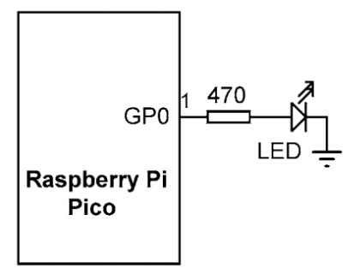

(Figure 1 : Circuit diagram for an external LED flashes the SOS signal in Morse code)

Objective 5
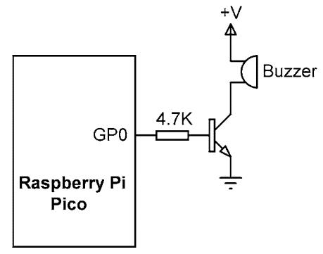

(Figure 2: Circuit diagram to blink an external LED with buzzer sends the SOS signal in Morse code using Raspberry Pi Pico and a transistor.)

Observation:

Objective 2
Table 1: (Resistance Measurement)

Sl |  | Colour code of | Theoretical/colour | Measured |  | % of error
No. |  | resistors | code value, T | (DMM), M |  | − |  | Remark
No. |  | resistors | code value, T | Value |  | = |  | Remark
1 |  | Red, Black, |  |  |  |  | ×
 |  | Orange, Gold
2
3
4
5

INTERNET OF THINGS (IOT) PROJECT USING PYTHON (CSE 4110)

Identification and verification of different basic electronic components and implementation of an efficient electronic circuit in which an external LED with buzzer sends the SOS signal in Morse code using Raspberry Pi Pico and a transistor.
POST-LAB IOT Projects using Python (CSE 4110) ASSIGNMENT
Experiment – 2

Objective 3

Table 2: (Diode Verification)

Sl No. | Type of Diode | Forward Bias | Reverse Bias | Remark
 |  | Voltage | Voltage
1 | 1N4148 (Silicon Diode)
2 | Red LED
3 | Blue LED
4 | Green LED

Table 3: (Transistor Verification)

1
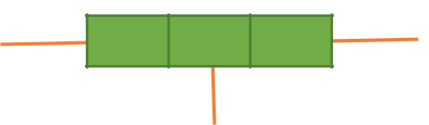
P/N N/P P/N

2

3
Transistor Schematic Diagram

Unknown | Biasing | Voltage | Voltage | Type of | V1>V2 | V2>V1 | Remark
Transistors |  | between | between | Transistor
 |  | Terminal 1 | Terminal | (NPN or
 |  | & 2 (V1) | 2&3(V2) | PNP)
 |  |  |  |  | 1 : _____ | 1 : _____
 | Forward Bias |  |  |  | 2: _____ | 2: _____
Unknown |  |  |  |  | 3: _____ | 3: _____
Transistor
1 | Reverse Bias
 |  |  |  |  | 1 : _____ | 1 : _____
 | Forward Bias |  |  |  | 2: _____ | 2: _____
Unknown |  |  |  |  | 3: _____ | 3: _____
Transistor
2 | Reverse Bias

INTERNET OF THINGS (IOT) PROJECT USING PYTHON (CSE 4110)

Identification and verification of different basic electronic components and implementation of an efficient electronic circuit in which an external LED with buzzer sends the SOS signal in Morse code using Raspberry Pi Pico and a transistor.

POST-LAB IOT Projects using Python (CSE 4110) ASSIGNMENT
Experiment – 2

Objective 4

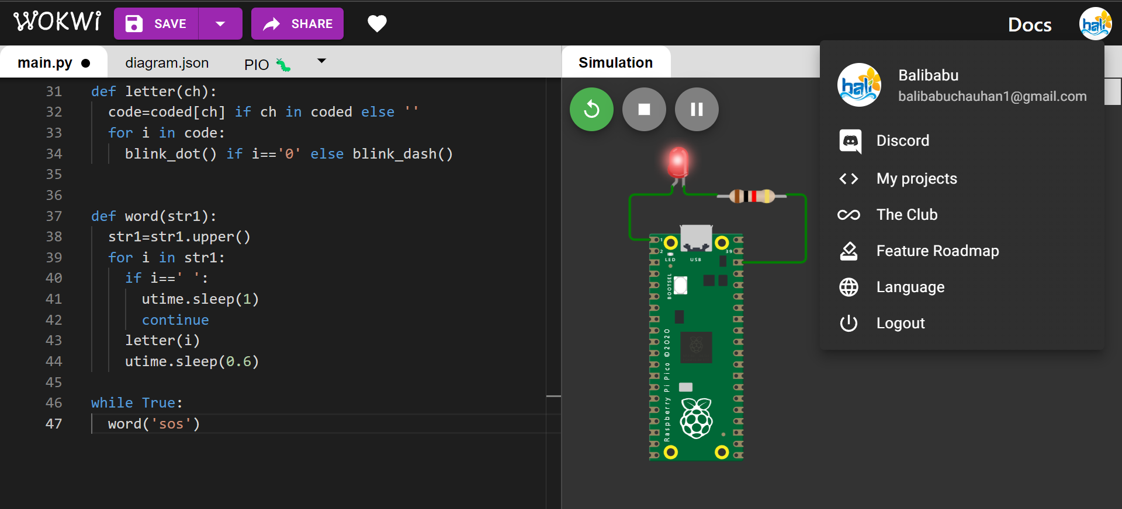

Figure 3: (Simulation based electronic circuit in which an external LED flashes the SOS signal in Morse code.)
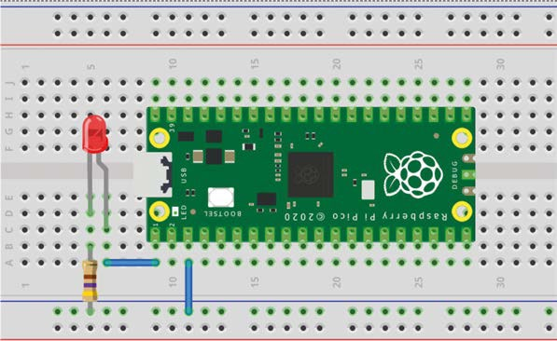
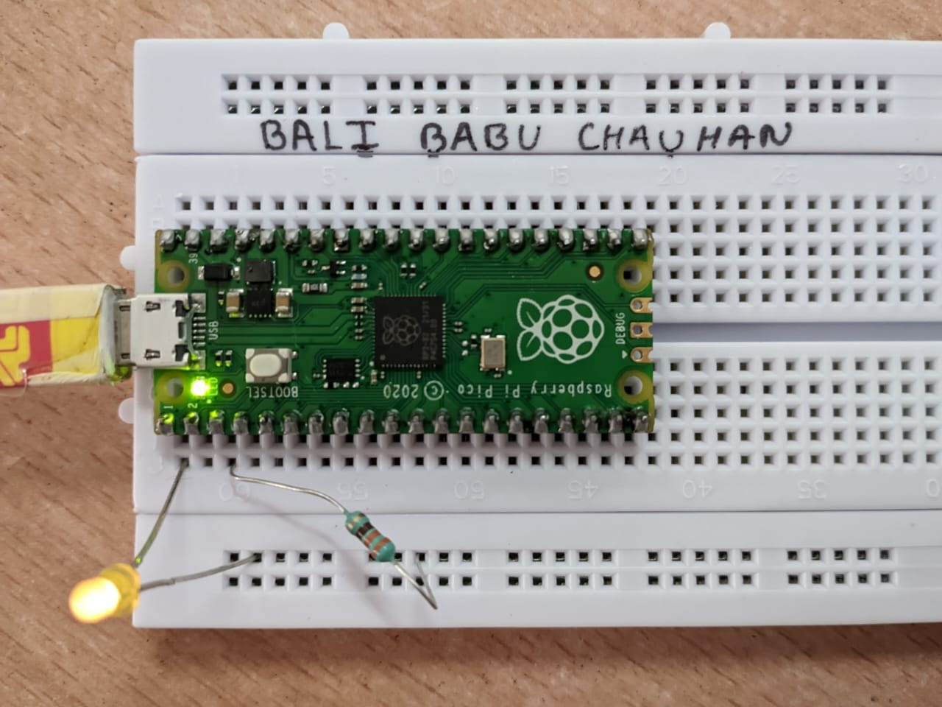

Figure 4: (Breadboard Schematic representation of an electronic circuit in which an external LED flashes the SOS signal in Morse code.)
Figure 5: (Hardware implementation based electronic circuit in which an external LED flashes the SOS signal in Morse code.)

Objective 5

Figure 5: (Hardware Implementation based more efficient electronic circuit in which an external LED with buzzer sends the SOS signal in Morse code using Raspberry Pi Pico and a transistor)

INTERNET OF THINGS (IOT) PROJECT USING PYTHON (CSE 4110)

Identification and verification of different basic electronic components and implementation of an efficient electronic circuit in which an external LED with buzzer sends the SOS signal in Morse code using Raspberry Pi Pico and a transistor.

POST-LAB IOT Projects using Python (CSE 4110) ASSIGNMENT
Experiment – 2

Codes:
Objective 4

print("Hello, Pi Pico!")

print("This is Experiment - 2 and Objective - 4")

print("Objective : 4 Implementation of an electronic circuit in which an external LED flashes the SOS signal in Morse code (three dots, followed by three dashes, followed by three dots) continuously using Raspberry Pi Pico. A dot is represented with the LED being ON for 0.25 seconds (Dot time) and a dash is represented with the LED being ON for 1 second (Dash time). The delay between the dots and dashes is set to 0.5 second (GAP time). This process is repeated continuously after 2 seconds of delay.")

from machine import Pin

from utime import sleep

dot = 0.25

dash = 1

gap = 0.5

ON=1

OFF=0

led = Pin(0,Pin.OUT)

while True:

for i in range(0,3):

led.value(ON)

sleep(dot)

led.value(OFF)

sleep(dot)

sleep(gap)

for i in range(0,3):

led.value(ON)

sleep(dash)

led.value(OFF)

sleep(dash)

sleep(gap)

for i in range(0,3):

led.value(ON)

sleep(dot)

led.value(OFF)

sleep(dot)

sleep(gap)

INTERNET OF THINGS (IOT) PROJECT USING PYTHON (CSE 4110)

Identification and verification of different basic electronic components and implementation of an efficient electronic circuit in which an external LED with buzzer sends the SOS signal in Morse code using Raspberry Pi Pico and a transistor.
POST-LAB IOT Projects using Python (CSE 4110) ASSIGNMENT
Experiment – 2

Objective 5

print("Hello, Pi Pico!")

print("This is Experiment - 2 and Objective - 5")

print("Objective : 5 Implementation of a more efficient electronic circuit in which an external LED with buzzer sends the SOS signal in Morse code using Raspberry Pi Pico and a transistor.")

from machine import Pin

from utime import sleep

dot = 0.25

dash = 1

gap = 0.5

ON=1

OFF=0

led = Pin(0,Pin.OUT)

while True:

for i in range(0,3):

led.value(ON)

sleep(dot)

led.value(OFF)

sleep(dot)

sleep(gap)

for i in range(0,3):

led.value(ON)

sleep(dash)

led.value(OFF)

sleep(dash)

sleep(gap)

for i in range(0,3):

led.value(ON)

sleep(dot)

led.value(OFF)

sleep(dot)

sleep(gap)

INTERNET OF THINGS (IOT) PROJECT USING PYTHON (CSE 4110)

Identification and verification of different basic electronic components and implementation of an efficient electronic circuit in which an external LED with buzzer sends the SOS signal in Morse code using Raspberry Pi Pico and a transistor.

